**Experiment-2**

**Aim: Creation of table in SQL**

**Syntax:-**CREATE TABLE table_name (  
    column1 datatype,  
    column2 datatype,  
    column3 datatype,  
   ....  
);

The column parameters specify the names of the columns of the table.

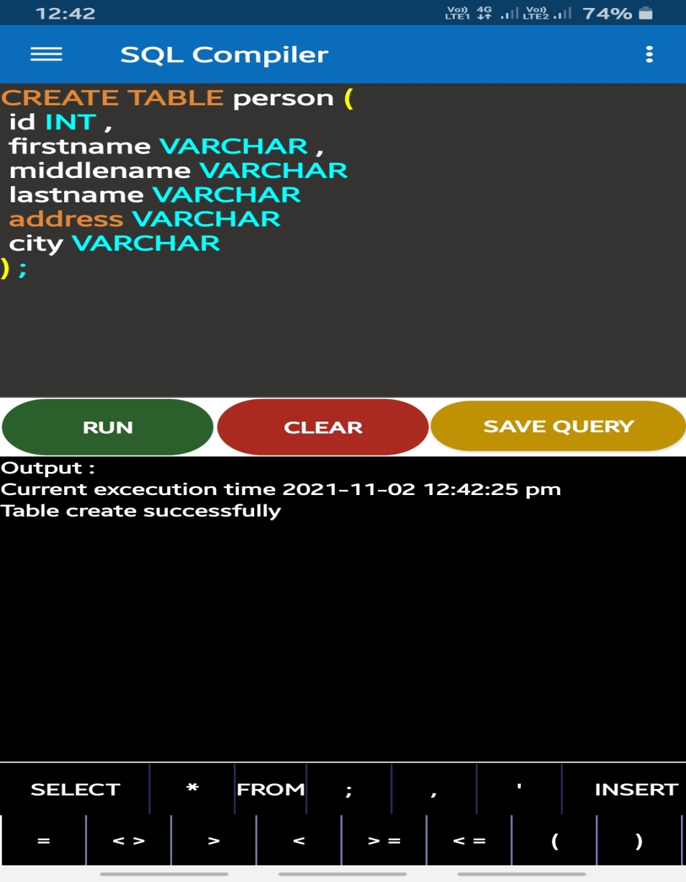The datatype parameter specifies the type of data the column can hold (e.g. varchar, integer, date, etc.).